**PLASMA DONOR APPLICATION**



**Team ID :PNT2022TMID48261**

**Faculty mentor: Team leadA.ANUSUDHA**

**M.Naseem banu Team member: Jeeva**

**Team member: Sopitha**

**Team member:K.Kaviya**

**PROBLEM SOLUTION**

**Category:**Cloud App Development

**Skills Required:**IBM Cloud,HTML,Javascript,IBM Cloud Object Storage,Python-Flask,Kubernetes,Docker,IBM DB2,IBM Container Registry.

**Project Description:**

During the COVID 19 crisis, the requirement of plasma became a high priority and the donor count has become low. Saving the donor information and helping the needy by notifying the current donors list, would be a helping hand. In regard to the problem faced, an application is to be built which would take the donor details, store them and inform them upon a request.

**Technical Architecture:**

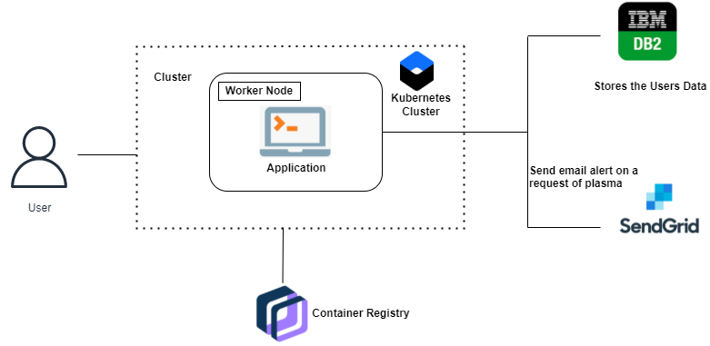

**Project Workflow:**

1. The user interacts with the application.
2. Registers by giving the details as a donor.
3. The database will have all the details and if a user posts a request then the concerned blood group donors will get notified about it.